Charging Station Load

Group 2

Sunny Shah

Elliot Goldberg

A driver of a Nissan Leaf arrives at 9: 00 AM with 21 kWh drawn from the battery in the commute from home to F-lot. They plug into a Level-2 charger.

The full capacity of the Nissan lead is 30kWh and the charger on the leaf is limited to 6.6 kh [1]. Thus, with 70 percent of the battery depleted to 9 kWh. It will take 21kWh/6.6 kh= 3 hours to charge the car.

The first driver does not remove the car until 5:00 PM, but car 2 arrives at F-lot around 2:00 PM with again 70 percent of battery depletion and will again take another 4 hours to charge. Figure 1 shows the charging load vs. time for the multiple load scenarios.

Figure 1. Load scenarios using the Nissan Leaf with multiple cars.

|  |  |
| --- | --- |
| Hour of Year | Load (kW) |
| 1 | 0 |
| 2 | 0 |
| 3 | 0 |
| 4 | 0 |
| 5 | 0 |
| 6 | 0 |
| 7 | 0 |
| 8 | 6.6 |
| 9 | 6.6 |
| 10 | 6.6 |
| 11 | 6.6 |
| 12 | 6.6 |
| 13 | 0 |
| 14 | 6.6 |
| 15 | 6.6 |
| 16 | 6.6 |
| 17 | 6.6 |
| 18 | 0 |
| 19 | 0 |
| 20 | 0 |
| 21 | 0 |
| 22 | 0 |
| 23 | 0 |
| 24 | 0 |

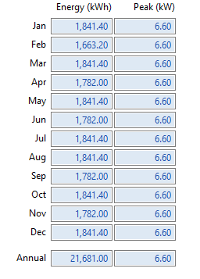

Figure 3. SAM Monthly Load Profile.

Figure 2. car load as imported into SAM from csv file. Using the load of the week as shown in Figure 1 and adding weekend load of two hours.

In the case that they system must handle two cars, ass seen in Figure 3. SAM shows that an annual load of about 21,681 kWh and a monthly average of 1806.75kWh. Using PVWatts and array of about 17.5 kW­­DC can be used to generate the AC energy needed for the F-lot solar canopy.

References.

[1] “The Nissan Leaf,” PluginCars.com, 09-Feb-2010. [Online]. Available: http://www.plugincars.com/nissan-leaf. [Accessed: 12-Mar-2017].